UNIT III
Quality Tools, Statistical Process Control, Six Sigma, Benchmarking and FMEA

3.1 The Seven Traditional Tools of Quality
The seven basic (or “old”) tools of quality are simple statistical and graphical techniques used to identify, analyse and solve quality-related problems in a process.
1. Cause-and-Effect Diagram (Ishikawa / Fishbone Diagram): Identifies many possible causes for an effect or problem and sorts the ideas into useful categories (commonly the 6Ms – Man, Machine, Material, Method, Measurement, Environment).
Steps in constructing a Cause-and-Effect diagram:
- Define the problem or effect to be analysed.
- Form a team to perform the analysis; the team uncovers potential causes through brainstorming.
- Draw the effect box and the horizontal centre line (the “spine”).
- Specify the major potential cause categories and join them as branches to the centre line.
- Identify the possible causes under each category, creating new categories if necessary.
- Rank the causes to identify those most likely to impact the problem.
- Take corrective action on the most probable causes.
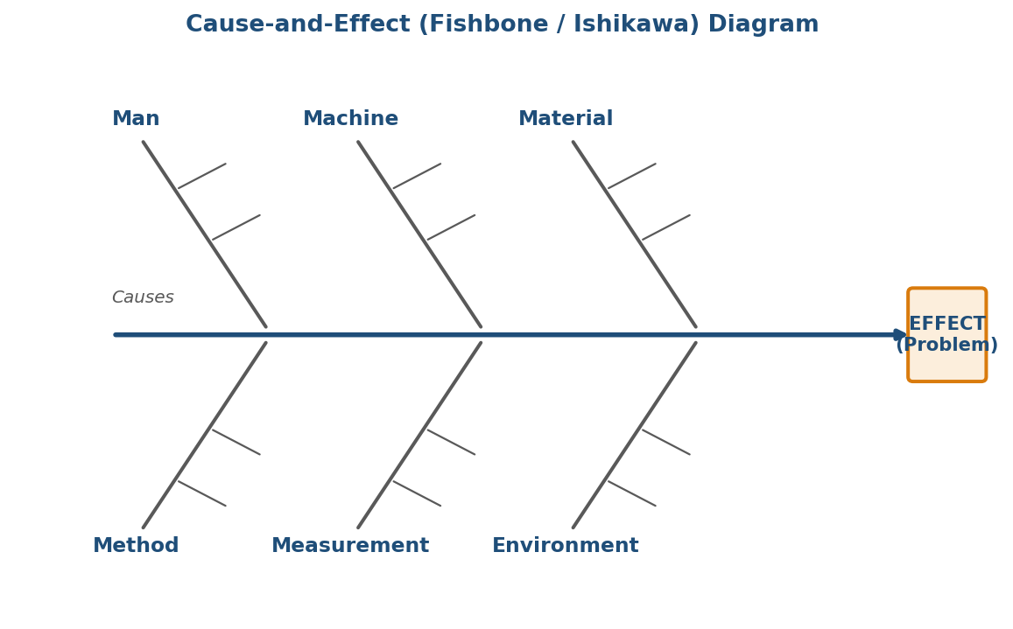
Fig. 3.1 Cause-and-Effect (Fishbone) Diagram showing the six major cause categories.
2. Check Sheet: A structured, prepared form used to collect and record data in real time at the point where it is generated. It is a generic tool that can be adapted for many purposes and is usually the first step before building a Pareto chart or histogram.
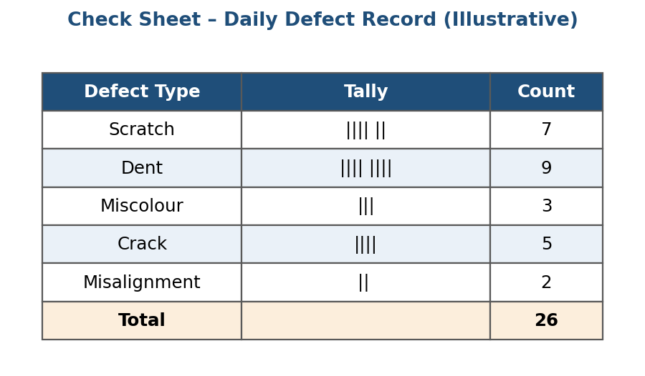
Fig. 3.2 A simple check sheet used to tally defects by type during an inspection shift.
3. Control Chart: A graph used to study how a process changes over time. Data are plotted in time order against a centre line and statistically calculated Upper and Lower Control Limits (UCL/LCL). Comparing current data with the control limits shows whether the process variation is consistent (in control, due to chance causes) or unpredictable (out of control, due to assignable causes).
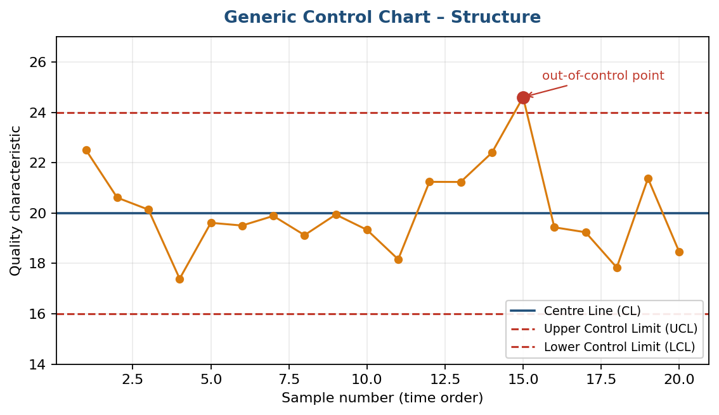
Fig. 3.3 Structure of a control chart: centre line, UCL/LCL, and a point outside the limits signalling an assignable cause.
4. Histogram: The most commonly used graph for showing a frequency distribution – how often each different value, or range of values, occurs in a set of data. It reveals the shape, spread and central tendency of the data at a glance.
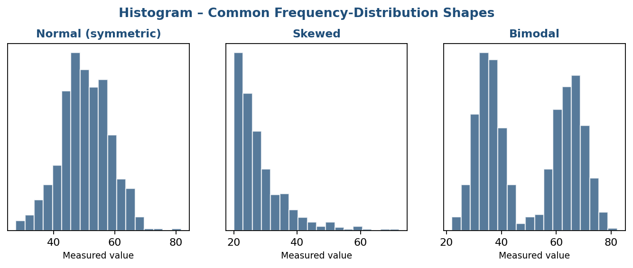
Fig. 3.4 Common histogram shapes: normal (symmetric), skewed, and bimodal.
5. Pareto Chart: A bar graph, arranged in descending order of frequency, that shows which factors are the most significant. It is based on the Pareto Principle (the 80/20 rule) – roughly 80% of problems arise from 20% of the causes – helping teams focus on the “vital few” causes rather than the “trivial many.”
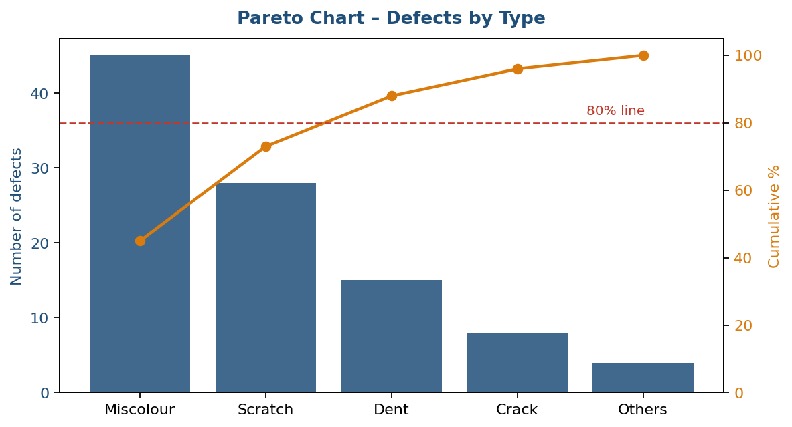
Fig. 3.5 Pareto chart of defect types with the cumulative-percentage line and the 80% cut-off.
6. Scatter Diagram: Plots pairs of numerical data, one variable on each axis, to look for a relationship between the two variables. The pattern formed by the points shows the type (positive, negative or none) and strength of the relationship.
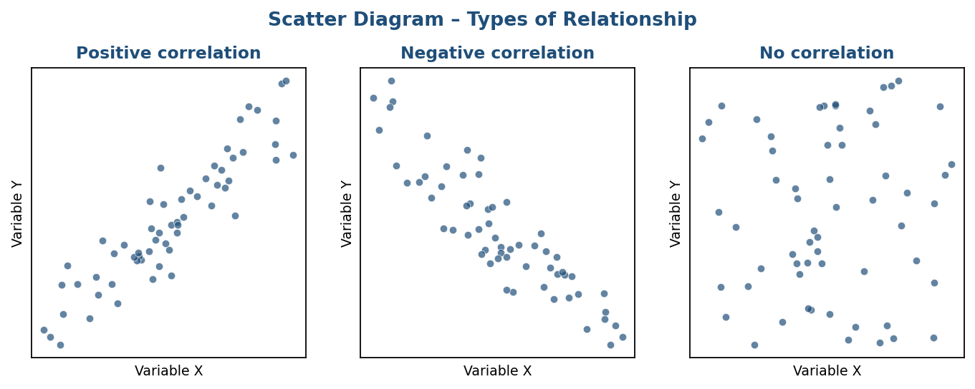
Fig. 3.6 Scatter diagrams illustrating positive, negative, and no correlation.
7. Stratification: A technique that separates data gathered from a variety of sources or conditions – such as shift, machine, operator or supplier – so that patterns specific to each source can be seen. (Some lists replace stratification with the flow chart or run chart.)
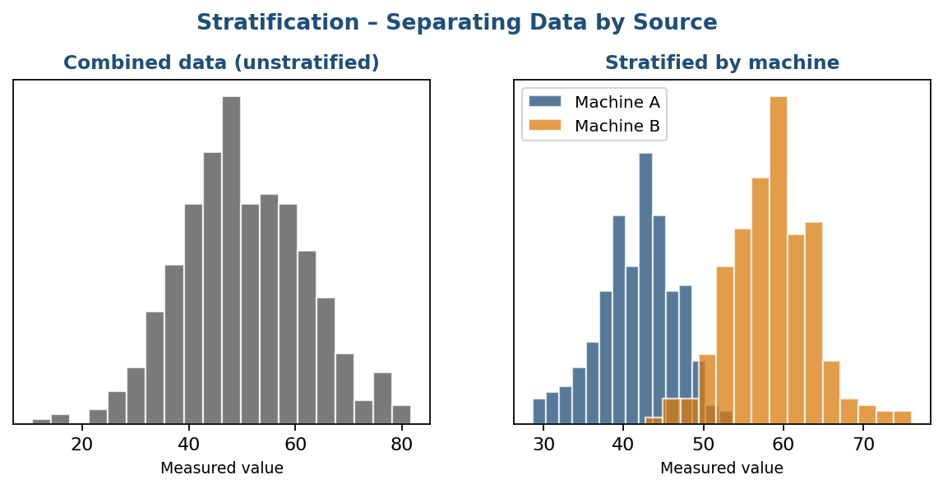
Fig. 3.7 The same data set before and after stratification by machine, revealing two distinct sub-populations.

3.2 New Seven Management Tools
While the seven basic tools are mainly numerical, the “New Seven” (or Seven Management and Planning Tools) are used to plan, organise and manage qualitative data – ideas, opinions and issues – especially for complex, unstructured problems.
1. Affinity Diagram (KJ Method): A special brainstorming tool that organises a large amount of disorganised facts or ideas into groupings based on their natural relationships. It was developed in the 1960s by Japanese anthropologist Jiro Kawakita (hence “KJ method”) and is used when a team faces many facts or ideas in apparent chaos, or when an issue seems too large and complex to grasp.
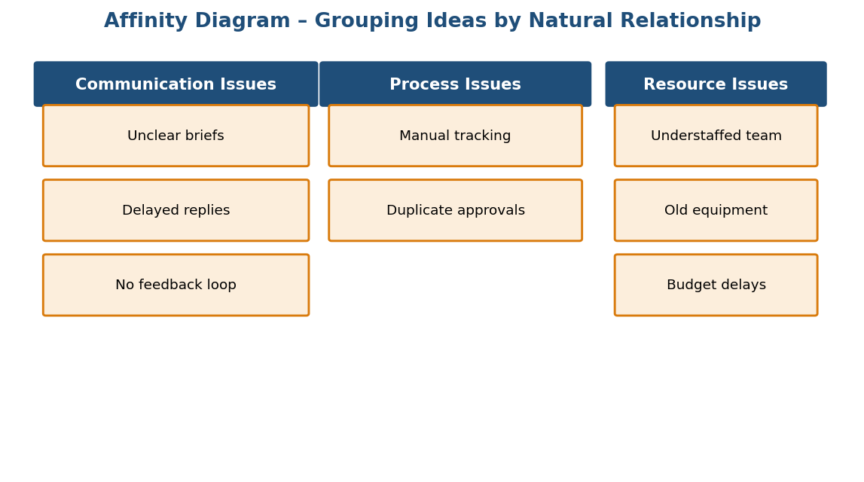
Fig. 3.8 Affinity diagram grouping raw ideas into natural theme clusters.
2. Interrelationship Diagram: Displays all the interrelated cause-and-effect relationships and factors involved in a complex problem and clarifies the desired outcome. Building the diagram helps a team analyse the natural links between different aspects of a complex situation.
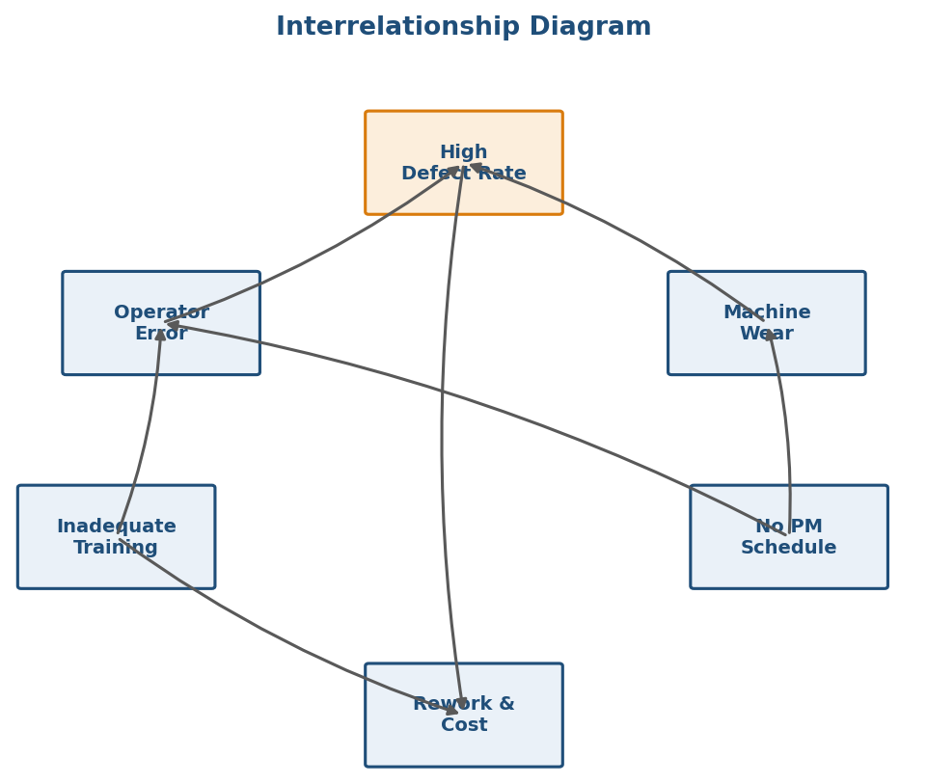
Fig. 3.9 Interrelationship diagram showing how root causes drive a central problem and its consequence.
3. Tree Diagram: Used to break down broad categories or goals into finer and finer levels of detail, mapping the tasks required to accomplish a goal. It shifts the team’s focus from generalities to specifics.
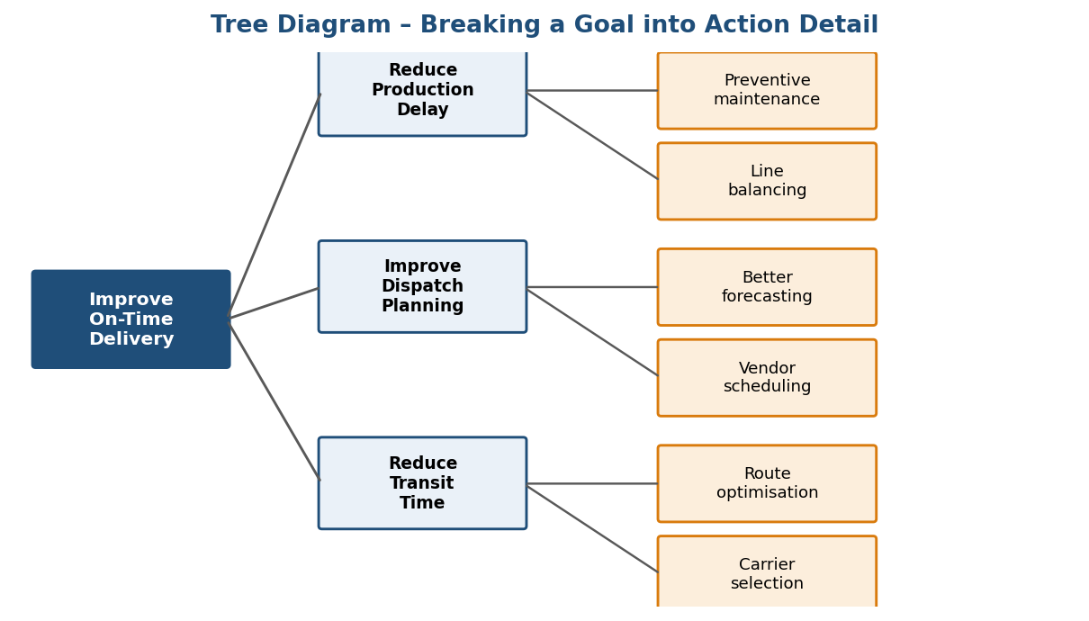
Fig. 3.10 Tree diagram decomposing a goal into means and detailed actions.
4. Prioritization Matrix: Used to prioritise items and describe them in terms of weighted criteria. It combines tree- and matrix-diagramming techniques to make a pair-wise evaluation of options and narrow them down to the most desirable one(s). Common applications include return-on-investment (ROI) or cost–benefit analysis, and urgency-versus-importance time-management matrices.
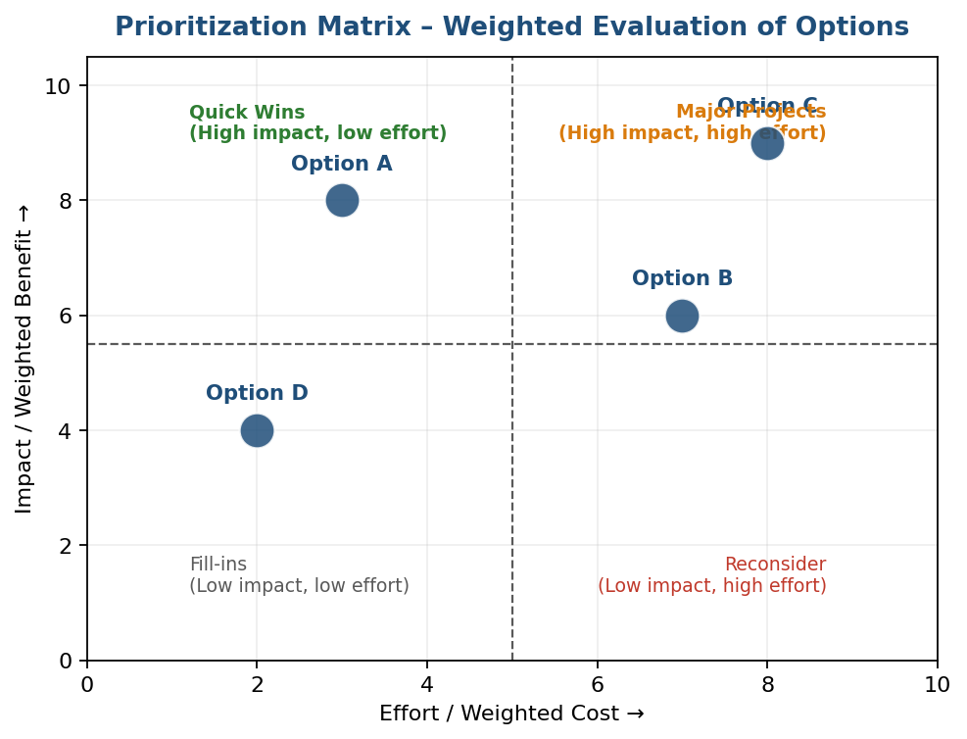
Fig. 3.11 Prioritization matrix plotting options by impact versus effort.
5. Matrix Diagram (Quality Table): Shows the relationship between two or more sets of elements, and at each intersection indicates whether a relationship exists and, if so, its strength. It helps analyse complex situations by exposing interactions and dependencies. Six shapes are possible depending on the number of groups compared: L, T, Y, X, C and roof-shaped.
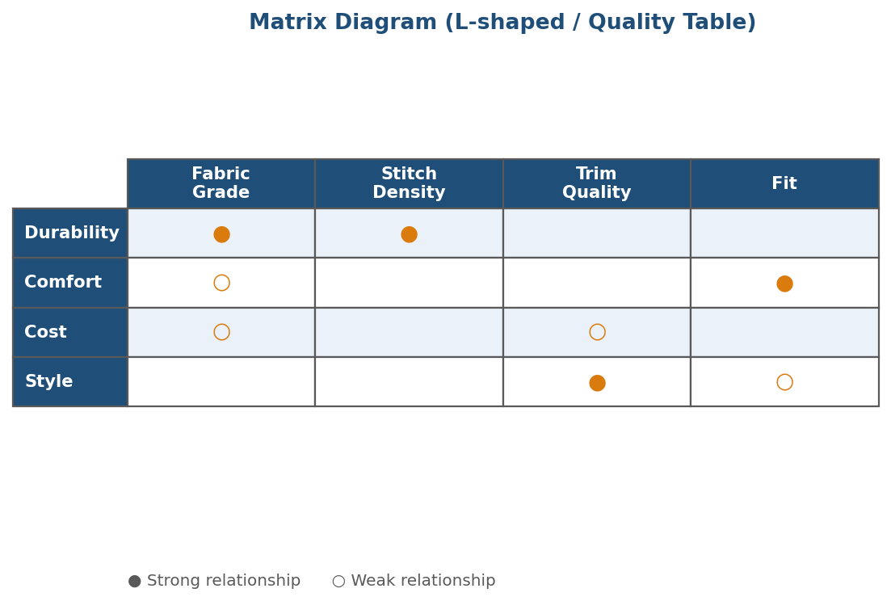
Fig. 3.12 L-shaped matrix diagram relating customer requirements to product features.
6. Process Decision Program Chart (PDPC): Extends the tree diagram a level or two further to identify risks and countermeasures for the bottom-level tasks of a plan. Different-shaped boxes highlight risks and possible countermeasures (often shown as “clouds” to indicate their uncertain nature). It is similar to FMEA in that both identify risks and contingency actions, though FMEA additionally rates the relative risk of each failure point.
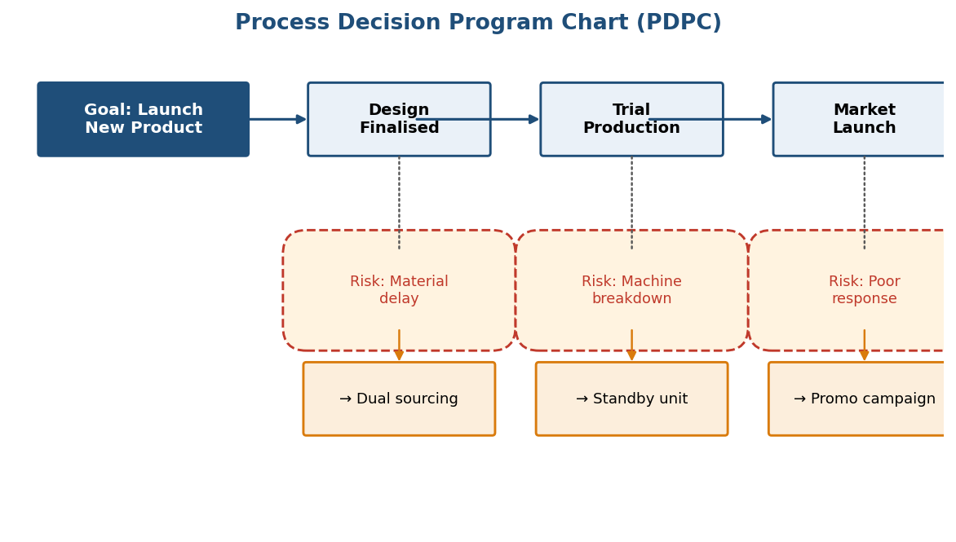
Fig. 3.13 PDPC extending a project plan with risks (dashed clouds) and countermeasures at each stage.
7. Activity Network Diagram: Used to plan the appropriate sequence or schedule for a set of tasks and subtasks, especially when some subtasks must occur in parallel. It helps determine the critical path (the longest sequence of dependent tasks) and helps teams sequentially define, organise and manage a complex set of activities.
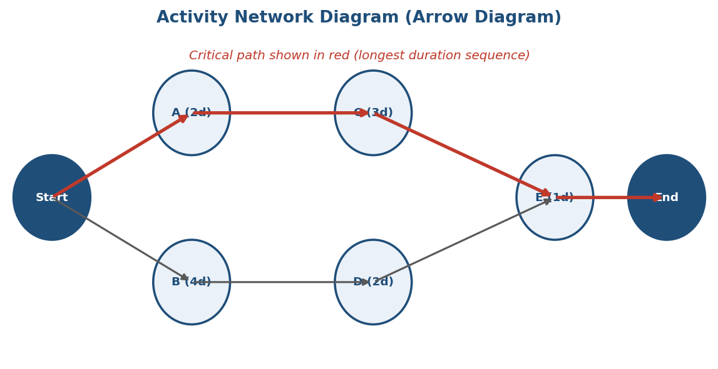
Fig. 3.14 Activity network diagram with the critical path highlighted in red.

3.3 Statistical Fundamentals
Statistics is the science that deals with the collection, tabulation, analysis, interpretation and presentation of quantitative data. Data collected for quality-control purposes are obtained by direct observation and classified as:
- Variables: measurable quality characteristics, such as length, weight or diameter.
- Attributes: quality characteristics classified as either conforming or non-conforming to specification – for example, a “go/no-go” gauge reading.

Measures of Central Tendency and Dispersion
A measure of central tendency is a numerical value describing how data tend to build up around the centre. Three common measures are used:
- Average (Mean): the sum of all observations divided by the number of observations.
- Median: the value that divides a series of ordered observations so that the number of items above it equals the number below it.
- Mode: the value that occurs with the greatest frequency in a data set. A distribution may have no mode, or be uni-modal, bi-modal or multi-modal.
A measure of dispersion describes how the data are spread out on either side of the central value:
- Range: the difference between the highest (Xₕ) and lowest (Xₗ) observations in a series.
- Standard Deviation (S): measures the spreading tendency of the data about the mean; the larger the standard deviation, the greater the variability in the data.

Population and Sample
The population is the entire collection of items under study – for example, an hour’s production, a week’s production, or all the shafts manufactured. Since it is rarely possible to measure an entire population, a sample – a smaller portion selected to represent the population – is used instead. Sampling becomes necessary when:
- It is impossible to measure the entire population.
- It is too expensive to observe all the data.
- The required inspection is destructive (destroys the product).
- Testing the entire population would be too dangerous, as with a new medical drug.
Notation: X̄ (X-bar) is the sample average and μ (mu) is the population mean; S is the sample standard deviation and σ (sigma) is the population standard deviation.

Normal Curve
The normal curve represents the most common type of population distribution. It is symmetrical, uni-modal and bell-shaped, with the mean, median and mode all having the same value.
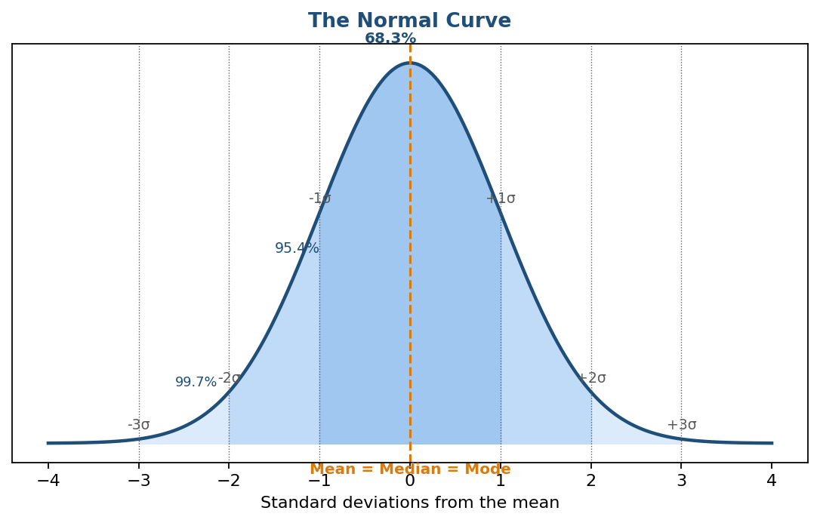
Fig. 3.15 The normal curve, showing the percentage of data falling within ±1σ, ±2σ and ±3σ of the mean.

3.4 Control Charts for Variables and Attributes
Variation is a law of nature – no two natural items in any category are ever exactly identical. Variation arises from two broad causes:
- Chance (common/natural) causes: inevitable, purely random, unidentifiable sources of variation inherent in almost every process. When only chance causes are present, the process is said to be in statistical control.
- Assignable (special) causes: result in unnatural variation; sources may include equipment, materials, environment or the operator.
The control chart is used to study variation and to distinguish chance causes from assignable causes. Every control chart has three basic components: a centre line (usually the mathematical average of all plotted samples); Upper and Lower Control Limits (UCL and LCL) that define the boundary of common-cause variation; and performance data plotted in time order. If a process is in control, nearly all sample points fall between the UCL and LCL.

Control Charts for Variables
Used for measurable (continuous) quality characteristics.
- Mean Chart (X̄ chart): monitors the process average over time.
- Range Chart (R chart): monitors the process variability (spread) over time. The X̄ and R charts are used together, since a shift in either the average or the spread of a process can signal a problem.
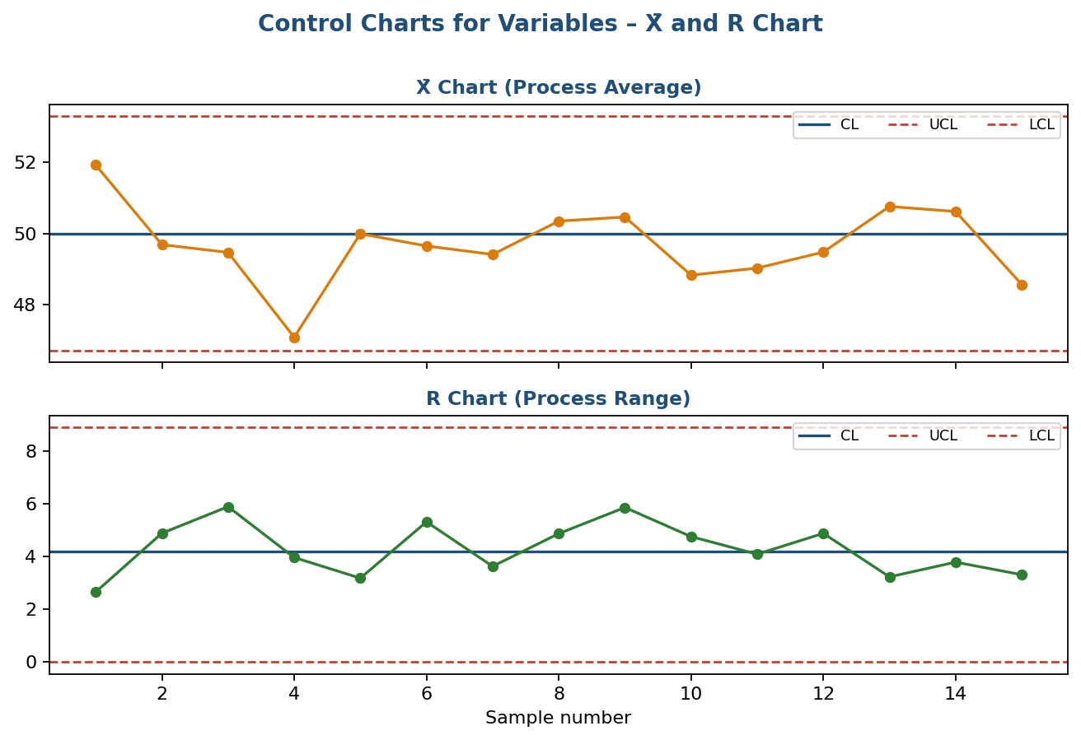
Fig. 3.16 X̄ and R charts used together to monitor process average and process spread.

Control Charts for Attributes
Used for count / go-no-go data.
- p-chart: monitors the proportion (fraction) of non-conforming units in a sample, for a fixed or varying sample size, where each unit is simply conforming or non-conforming.
- np-chart: monitors the number (count) of non-conforming units, for a constant sample size.
- c-chart: monitors the number of non-conformities (defects) per unit or inspection area, for a constant sample size, where a single unit can have more than one defect.
- u-chart: monitors the number of non-conformities per unit, for a fixed or varying sample size, where a single unit can have more than one defect.
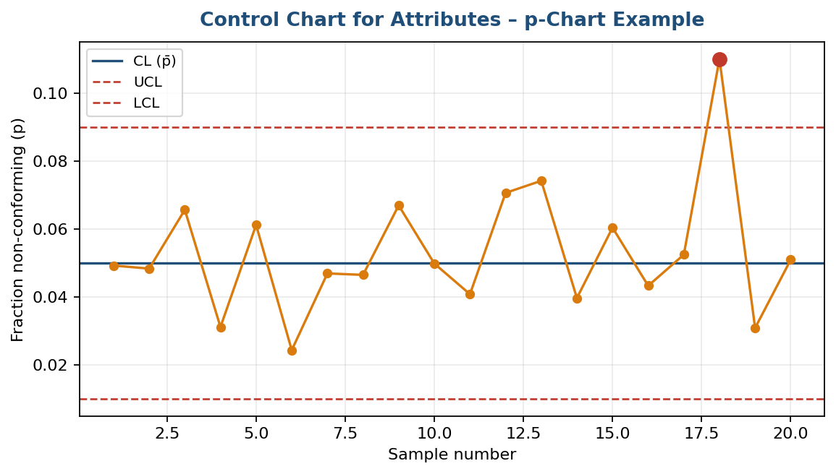
Fig. 3.17 A p-chart tracking the fraction of non-conforming units, with one out-of-control sample flagged.

3.5 Process Capability (Cp and Cpk)
Process capability analysis compares the actual, natural variation of a process (as measured from a control chart) with the specification limits set by the customer or design engineer, to determine whether the process is capable of consistently producing output within specification.
Process Capability Ratio, Cp = (USL − LSL) / 6σ – where USL and LSL are the Upper and Lower Specification Limits and σ is the process standard deviation. Cp measures potential capability and assumes the process is centred between the specification limits. As a general guideline, Cp ≥ 1.33 indicates a capable process, Cp = 1.00 indicates the process only just meets specification, and Cp < 1.00 indicates the process is not capable.
Process Capability Index, Cpk = min[(USL − X̄)/3σ, (X̄ − LSL)/3σ] – this additionally accounts for how well the process is centred within the specification limits, and is therefore a more realistic measure of actual capability. Cpk is always less than or equal to Cp; a large gap between the two indicates that although the process has the potential to be capable, it is not well centred within the specification limits.
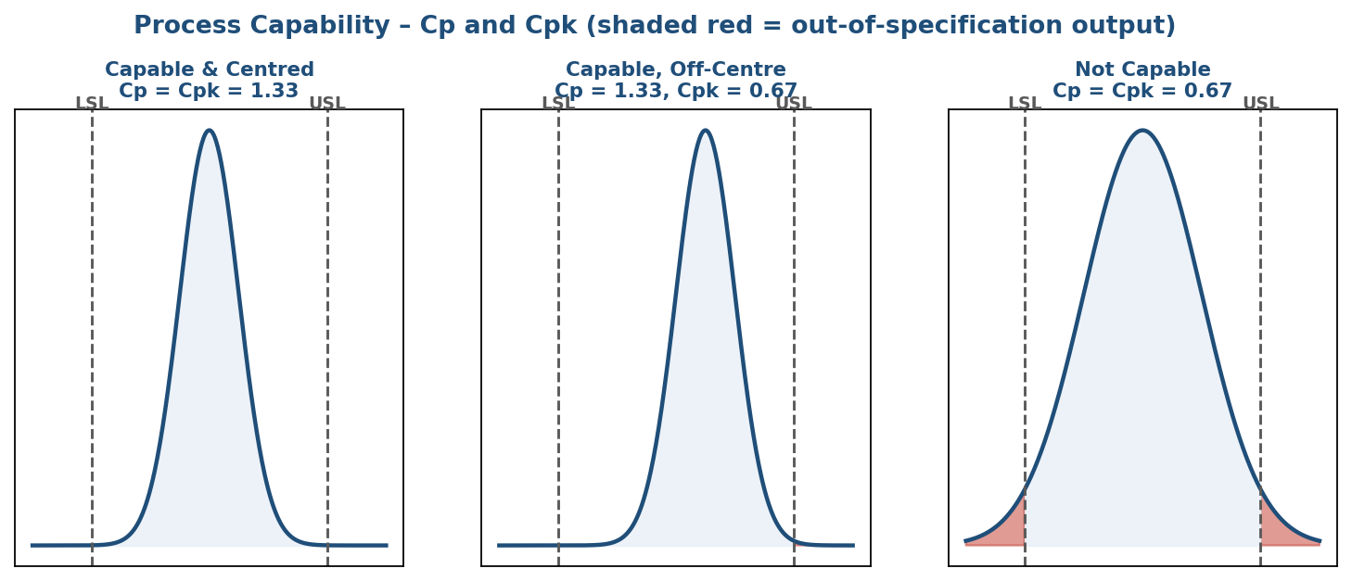
Fig. 3.18 Three process-capability scenarios: centred and capable, capable but off-centre, and not capable (red areas fall outside specification).

3.6 Six Sigma
Six Sigma is a data-driven, disciplined methodology for eliminating defects and reducing variation in any process – manufacturing, transactional or service.

Origin and History
- 19th century: German mathematician Carl Friedrich Gauss developed the bell curve (normal distribution), an early tool for detecting errors and defects.
- 1920s: American physicist and statistician Walter Shewhart demonstrated that a deviation of three sigma from the mean signals that a process needs improvement.
- 1980s: Motorola engineer Bill Smith developed and popularised Six Sigma to create more consistent product quality; Motorola reported saving $17 billion using Six Sigma by 2006.

What Six Sigma Means
“Six Sigma” refers to a process performance level of only 3.4 defects per million opportunities (DPMO) – that is, the process output lies within six standard deviations of the mean relative to the specification limits. It is a data-driven methodology that provides tools to define and evaluate every step of a process, aiming for continuous improvement until results are stable and predictable.
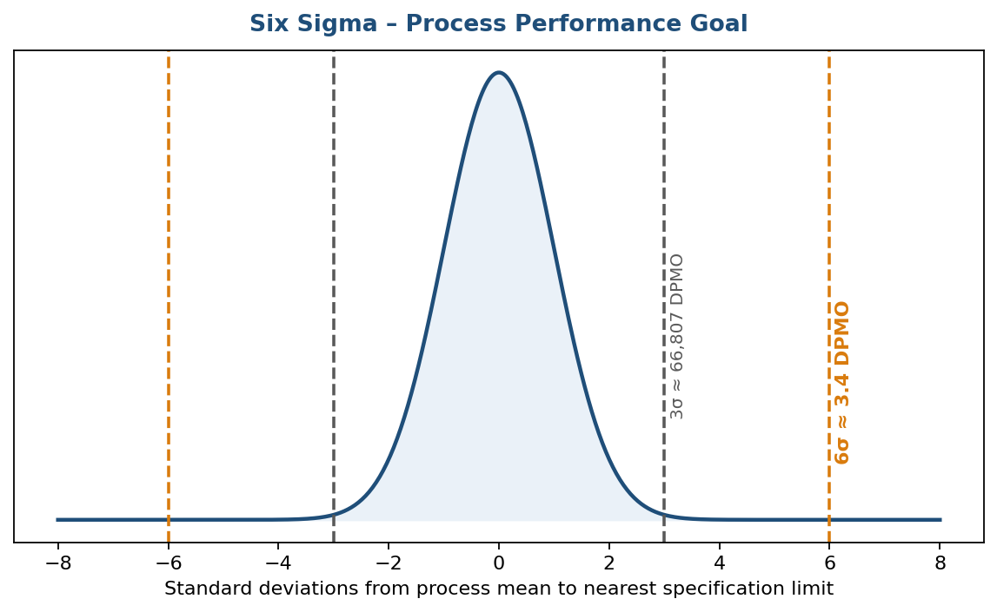
Fig. 3.19 Six Sigma compares a ±3σ process (about 66,807 DPMO) against the ±6σ goal (about 3.4 DPMO).

Six Sigma Belts (Levels of Expertise)
- White Belt: basic awareness of Six Sigma concepts.
- Yellow Belt: introduction to process-improvement theory and terminology.
- Green Belt: supports Black Belts with data collection and analysis on projects.
- Black Belt: leads Six Sigma improvement projects.
- Master Black Belt: mentors Black Belts and applies Six Sigma strategically across the organisation.

Methodologies of Six Sigma
DMAIC – used to improve an existing process: Define the problem and the project goals; Measure in detail the various aspects of the current process; Analyze the data to find the root causes of defects; Improve the process by eliminating the root causes; Control the process going forward to sustain the gains.
DMADV – used to design a new process, product or service: Define the project goals; Measure critical components of the process and product capabilities; Analyze the data and develop alternative designs, selecting the best one; Design and test the details of the process; Verify the design through simulations and a pilot run before handing it over to the client.
Successful Six Sigma implementation depends heavily on visible buy-in from top management and structured training of personnel at every belt level.

3.7 Benchmarking
Benchmarking is the practice of comparing business processes and performance metrics to industry bests and best practices from other companies – i.e., measuring the performance of a company’s products, services or processes against those of another business considered to be “best in class.” The dimensions typically measured are quality, time and cost, using indicators such as cost per unit, productivity per unit, cycle time or defects per unit. The point of benchmarking is to identify internal opportunities for improvement: by studying companies with superior performance and comparing their processes to one’s own, an organisation can implement changes that yield significant gains.
Continuous vs. dramatic improvement: There are two basic kinds of improvement opportunity that benchmarking can reveal. Continuous improvement is incremental – small, ongoing adjustments that accumulate into sizeable gains. Dramatic improvement, by contrast, can only come about through re-engineering the whole internal work process.

Reasons to Benchmark
- To set realistic, achievable and externally validated performance goals.
- To understand best-in-class practices and adapt them to one’s own processes.
- To become more competitive by closing performance gaps.
- To improve customer satisfaction through better quality, cost and delivery.
- To foster a culture of continuous improvement and external learning within the organisation.

Key Benefits of Benchmarking
- Improves employees’ understanding of cost structures and internal processes.
- Encourages team-building and cooperation in the interest of becoming more competitive.
- Enhances familiarity with key performance metrics and improvement opportunities company-wide.
In essence, benchmarking helps employees understand how one small piece of a company’s processes or products can be the key to major success – consistent benchmarking improves processes and procedures, gauges the effectiveness of past performance, reveals how competitors operate, and ultimately increases efficiency, lowers cost, and improves quality and customer satisfaction.

Types of Benchmarking
Benchmarking approaches fall into three primary categories:
Internal benchmarking: Analysing best practices already established by other teams or sites within one’s own company – for example, comparing the performance of one warehousing and shipping site against another, so the better-performing site’s methods can be shared company-wide.
Competitive benchmarking: Comparing products, services, processes and methods directly against one’s toughest competitors, to understand one’s position within the industry – for example, comparing customer-satisfaction ratings against a competitor’s product.
Strategic benchmarking: Looking beyond one’s own industry to identify world-class performance and best practices that can be adapted to one’s own procedures – the classic example is Southwest Airlines studying NASCAR pit crews (who change all four tyres and refuel a car in 12–16 seconds through clearly defined, timed tasks) to streamline its own gate maintenance, cabin cleaning and passenger-boarding processes.
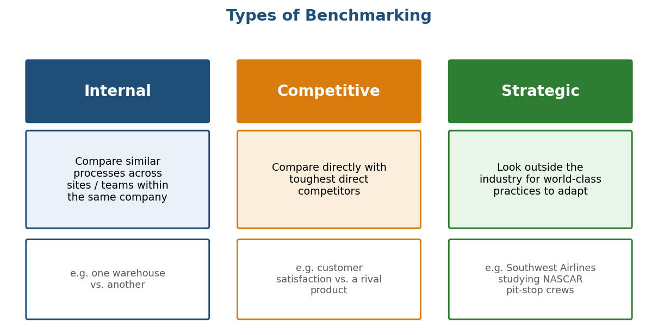
Fig. 3.20 The three categories of benchmarking – internal, competitive and strategic – with a representative example of each.

The Benchmarking Process
1. What to Benchmark: Identify the specific process, product or service to be benchmarked – usually a critical process that has a major impact on customer satisfaction or cost, or one known to be underperforming.
2. Understanding Current Performance: Thoroughly document and measure the organisation’s own process before comparing it with others, so that gaps can be accurately identified later.
3. Planning: Form a benchmarking team, decide the benchmarking method to be used (competitive, functional, internal or generic benchmarking) and identify potential benchmarking partners.
4. Studying Others: Collect data on the practices, processes and performance levels of the chosen benchmarking partners through site visits, surveys, published reports or industry associations.
5. Learning from the Data: Analyse the collected data to identify the size of the performance gap and, more importantly, the enabling practices responsible for the partner’s superior performance.
6. Using the Findings: Adapt – rather than simply adopt – the best practices identified to suit the organisation’s own culture and processes; set new performance targets and develop an action plan to close the gap. Benchmarking points out what changes will make the most difference – it is up to the organisation to actually put them in place.
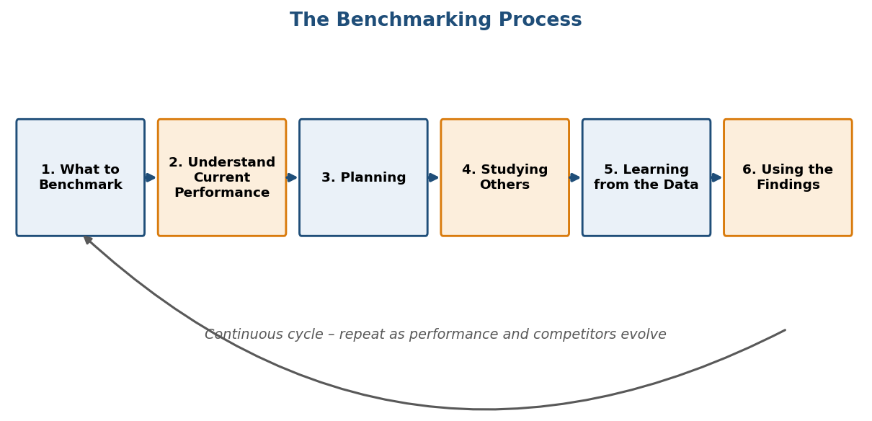
Fig. 3.21 The six-step benchmarking process, repeated continuously as performance and competitors evolve.

Detailed Eight-Step Benchmarking Process
A more granular, project-management view of the same process breaks it into eight practical steps:
1. Select a subject to benchmark: Senior management identifies which processes are critical to success, prioritises them by importance to stakeholders, and defines the measures to be collected.
x2. Decide which organisations to benchmark: Choose whether to study internal processes, a competitor, or a company outside the industry; since data from direct competitors is hard to obtain, several organisations are often studied together.
3. Document your current processes: Map the current process so that improvement areas can be identified and easily compared against the chosen organisation.
4. Collect and analyse data: Gather information through interviews, questionnaires and secondary sources such as websites, reports and news articles (noting that secondary information may be less reliable), then bring stakeholders together to analyse it.
5. Measure performance against the data collected: Compare the gathered data side by side with one’s own process metrics, identify what is causing the gaps, and brainstorm ideas to close them.
6. Create a plan: Develop an implementation plan with clearly defined goals, written with the company’s culture in mind and backed by full top-down buy-in to minimise resistance.
7. Implement the changes: Closely monitor the changes and employee performance, tweak processes that are not running smoothly, and ensure all employees are trained and have access to documentation.
8. Repeat the process: Once a new process is successfully implemented, review it for further refinement and move on to benchmark other areas or more ambitious projects – benchmarking is a continuous cycle, not a one-time project.

Pitfalls and Criticisms of Benchmarking
- Treating benchmarking as a one-time project rather than a continuous process.
- Copying practices directly (“industrial tourism”) without adapting them to the organisation’s own context.
- Benchmarking against the wrong partner, or benchmarking a process that is not critical to the business.
- Spending excessive time and cost on data collection without a clear implementation plan – confidential competitor data can be especially hard to obtain.
- Resistance to change from employees, often called the “not invented here” syndrome.
- Focusing only on numerical gaps while ignoring the underlying practices that create them.

3.8 Failure Mode and Effects Analysis (FMEA)
FMEA is a systematic, proactive method for evaluating a process to identify where and how it might fail, and to assess the relative impact of different failures, in order to identify the parts of the process most in need of change. Teams use FMEA to correct processes proactively rather than reacting to adverse events after failures occur – it is particularly useful when evaluating a new process before implementation, or when assessing the impact of a proposed change to an existing process. An FMEA review covers three linked questions for each step of the process:
- Failure modes: what could go wrong?
- Failure causes: why would the failure happen?
- Failure effects: what would be the consequences of each failure?

Intent of FMEA
The primary intent of FMEA is to identify and prioritise potential failure modes based on the severity of their effect, the likelihood of occurrence and the chance of detection – combined into a Risk Priority Number, RPN = Severity × Occurrence × Detection – and to eliminate or reduce high-risk failure modes through corrective design or process changes, ideally before the product reaches the customer.
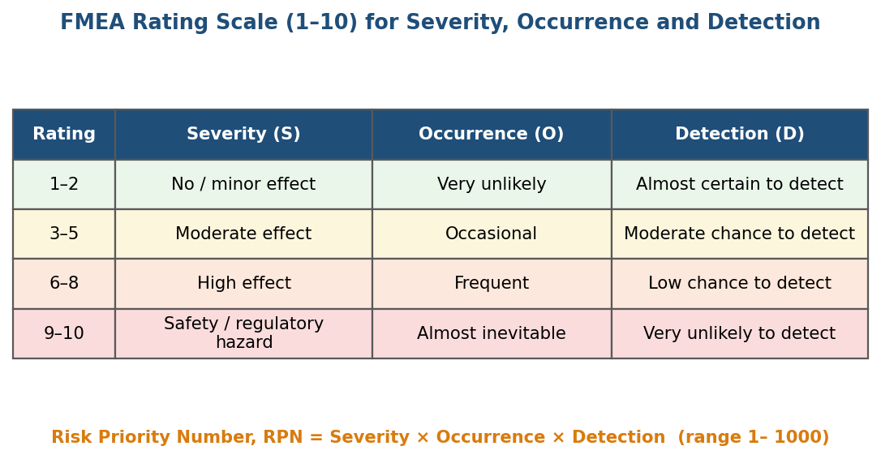
Fig. 3.22 Typical 1–10 rating scale used to score Severity, Occurrence and Detection when calculating the RPN.

Documentation
FMEA is recorded on a standard worksheet that typically includes:
- The item / process step and its function.
- The potential failure mode(s).
- The potential effect(s) of failure and its Severity rating.
- The potential cause(s) of failure and its Occurrence rating.
- Current controls and the Detection rating.
- The Risk Priority Number (RPN).
- Recommended corrective action(s), responsibility and target date.
- The revised RPN after the action is implemented.
This documentation is a “living document” – it should be updated whenever the design or process changes, or whenever a new failure mode is discovered.

Stages of FMEA
1. Design FMEA (DFMEA): Carried out during the product design stage, before the design is released for production. It analyses failures that could arise from design weaknesses – such as material selection, geometry or tolerances – and their effect on the end user or on subsequent manufacturing and assembly operations.
2. Process FMEA (PFMEA): Carried out during process and manufacturing planning. It analyses failures that could arise from the manufacturing or assembly process itself – such as machine variation, operator error or method – assuming the design is sound, and focuses on process control and inspection to prevent defective output from reaching the customer.

The Ten Steps of a Process FMEA
Since each step builds on the previous one, a Process FMEA is carried out step-wise:
Step 1 – Review the process: Use a process flow chart to identify each process component and list it in the FMEA table; if the scope feels too big, break it into smaller, more manageable chunks.
Step 2 – Brainstorm potential failure modes: Review existing documentation and data for every way each component could fail; the initial list should be exhaustive and can be pared down later.
Step 3 – List potential effects of each failure: Identify the impact each failure would have on the end product or on later process steps – a single failure can have more than one effect.
Step 4 – Assign Severity rankings: Rate the severity of the consequences of each failure.
Step 5 – Assign Occurrence rankings: Rate how likely each failure is to occur, using a customised ranking scale as a guide.
Step 6 – Assign Detection rankings: Rate the chance that the failure will be detected before it occurs.
Step 7 – Calculate the RPN: Multiply Severity × Occurrence × Detection for each failure mode.
Step 8 – Develop the action plan: Decide which failures to act on, focusing on the highest RPNs first, and define who will do what by when.
Step 9 – Take action: Implement the improvements identified by the FMEA team.
Step 10 – Calculate the resulting RPN: Re-evaluate each failure once improvements are made, to confirm and quantify the impact of the changes.
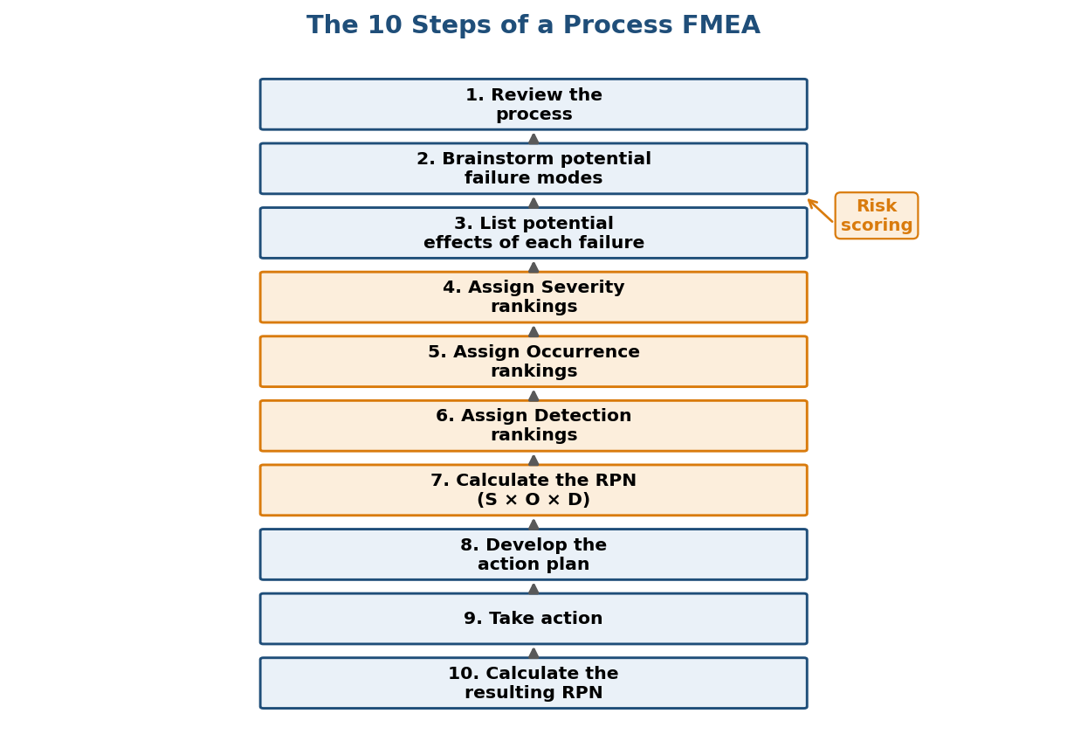
Fig. 3.23 The ten sequential steps of a Process FMEA, from reviewing the process to recalculating the RPN after corrective action.

Illustrative Application – FMEA in an Equipment Maintenance Plan
FMEA is often used as the centrepiece of an equipment maintenance plan (EMP) aimed at minimising the impact of unplanned failures on safety, environment and profitability. A criticality analysis – a cross-functional exercise involving Operations, Maintenance, Engineering and Materials Management – is first used to rank plant assets and select which equipment to study. The team then builds a Functional Block Diagram (FBD) showing how the equipment’s components interact, and calculates a baseline Overall Equipment Effectiveness (OEE), where OEE = Availability × Performance × Quality. The FMEA itself is then carried out in two phases: Phase 1 (Definition and Identification) documents each component’s function, functional failure, failure modes, causes, effects and current controls; Phase 2 (Quantifying, Prioritising and Mitigating Risk) assigns Severity, Occurrence and Detection scores to calculate the RPN for every failure mode, prioritises the top-scoring risks (typically the top 20%), and defines mitigation tasks – detecting failures early on their potential-failure curve, or eliminating them altogether through re-design.

UNIT III – Questions: Part A
- State the objectives of attribute control charts.
- Define the Six Sigma problem-solving methodology.
- What are the New Seven Management Tools?
- List the Seven Tools of Quality.
- State the uses of the Cause-and-Effect (C&E) diagram.
- Define Six Sigma.
- What are the various shapes of a histogram?
- Differentiate between population and sample.
- State the sources of variation in a process.
- Define a run chart.
- Define a control chart.
- What are the various patterns observed in a scatter diagram?
- Define process capability. What do Cp and Cpk indicate?
- Define benchmarking.
- List the stages involved in the benchmarking process.
- What are the types of benchmarking?
- Differentiate continuous improvement from dramatic improvement.
- State any two pitfalls of benchmarking.
- Define FMEA and state its intent.
- Differentiate between Design FMEA and Process FMEA.
- What is meant by the Risk Priority Number (RPN)?
- List the ten steps of a Process FMEA.

UNIT III – Questions: Part B
- Explain the seven traditional tools of quality with a suitable example for each.
- Explain the new seven management tools with a neat sketch for each.
- Explain the DMAIC and DMADV methodologies of Six Sigma.
- Explain process capability. Distinguish between Cp and Cpk with the help of a diagram.
- Explain the benchmarking process and the reasons to benchmark.
- Explain the types of benchmarking with suitable examples.
- What is FMEA? Explain its stages and the detailed steps involved in a Process FMEA.

